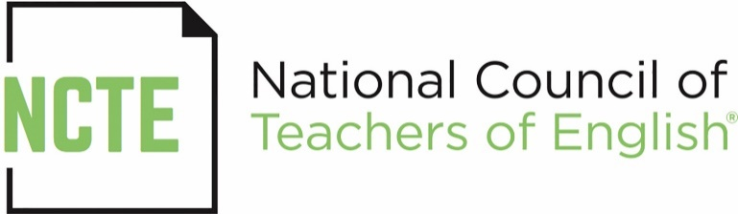

FOR IMMEDIATE RELEASE

Georgia Council of Teachers of English Honored with 2017 NCTE Affiliate Excellence Award

The Georgia Council of Teachers of English has been named as one of seven recipients of the 2017 NCTE Affiliate Excellence Award, given by the National Council of Teachers of English (NCTE). The affiliate, whose president is Julie Rucker of Tifton, Georgia, has won the award fifteen times.

The Affiliate Excellence Award was established in 1996 to honor NCTE affiliates that meet high standards of performance for programming and promote improvement in English language arts teaching.

Qualifications for the award represent standards of excellence to which all NCTE affiliates should aspire. Award winners fulfilled at least eight different criteria for excellent affiliate programming during the school year of application. The required criteria include:

- increasing membership in the affiliate or NCTE;
- publishing an affiliate communications instrument at least twice a year;
- conducting at least one professional development program for members;
- completing the annual affiliate report to NCTE by the deadline;
- achieving accomplishments such as implementing and maintaining a cultural diversity plan;
- developing a program to encourage new teachers into the profession;
- participating in an NCTE Affiliate Leadership Meeting;
- participating in at least three affiliate-sponsored activities at the NCTE Annual Convention.

The award winners will be announced at the 2017 NCTE Annual Convention in St. Louis, during the Affiliate Roundtable Breakfast on Sunday, November 19.

Other affiliates of excellence include Iowa Council of Teachers of English, Montana Association of Teachers of English Language Arts, New Jersey Council of Teachers of English, Ohio Council of Teachers of English Language Arts, Texas Council of Teachers of English Language Arts, and Virginia Association of Teachers of English.

For more information about the NCTE Affiliate Excellence Award, see
http://www.ncte.org/affiliates/awards/excellence.

Contact: Millie Davis, Senior Developer, Affiliates, 217-278-3634, mdavis@ncte.org

###

The National Council of Teachers of English (http://www.ncte.org), with 25,000 individual and institutional members worldwide, is the nation’s oldest literacy organization. With the expertise of its members, NCTE has led the nation in its most important decisions and trajectories around preK–16+ literacy/writing/literature thinking. NCTE is dedicated to improving the teaching and learning of English and the language arts at all levels of education. Please follow us on Twitter and Facebook.

